Chirala college of Engineering: Chirala
Department of ECE Faculty Profile
Name of the Faculty | G S A J MANI KUMAR |  |  |  |  |  | 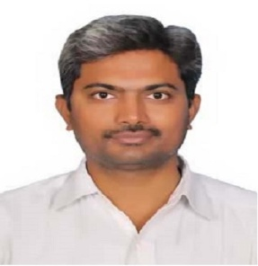
Designation | Associate Professor
Department | Electronics and Communication Engineering
Address | VETAPALEM
Phone No. | 9247592160
Email | manikumar@cecc.co.in
Web Page (if any)
Subjects Thought | 1. Satellite Communications  2. Telecommunication Switching Systems and Networks  3. Data Communication Systems  4. Antennas and Wave Propagation  5. Computer Networks |  |  |  | 6. Cellular and Mobile Communications  7. Switching Theory and Logic Design  8. Digital Communications  9. Optical Communications  10. Wireless Communications
Areas of Interest/Specialization | Communications
Experience in Years | Academics | 15
 | Industry | --
 | Research | --
Educational Qualifications | UG | B.Tech
 | PG | M.Tech
 | M.Phil | --
 | Ph.D | --
 | Others | Diploma in Spoken English (from Vivekananda Institute of Human Excellence, Sri Rama Krishna Math, Domalguda, HYD).
Ph.D Thesis Title
Research Publications in Journals (in IEEE Format) | NIL
Papers Published in Conference Proceedings (IEEE Format) | 05
Faculty Development/ Workshops Programs attended | 06
No.OfNational Conferences | Attended |  | NIL |  |  | Organized |  | NIL
No.OfInternational Conferences | Attended |  | NIL |  |  | Organized |  | NIL
Google Scholar ID | NO
Vidwan Profile | NO
Web of Science ID | NO
Scopus Link: | NO
Orchid LINK: | NO
Projects handled |  | UG |  | PG |  | M.Phil |  | Doctorate
 | Awarded | 25 |  | 6 |  | NIL |  | NIL
 | Undergoing | 01 |  | Nil |  | NIL |  | NIL
Awards & Distinctions | NIL
Administrative Assignments Handled | 1. In-charge of Examinations, JCS for Polytechnic Examinations, Co-ordinator for State level Examinations conducted by AP Government.
Professional membership : | ISTE
Any other Achievements | NIL

