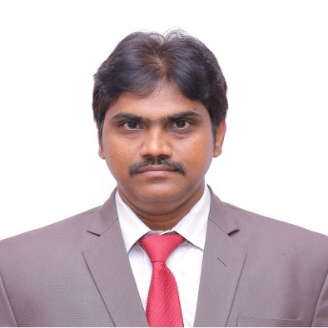

Dr.D.Jagadish
Principal
Chirala Engineering College (Autonomous)
Chirala

Educational Qualifications:
Degree/  Course | Duration | Department | Specialization | Name of the University
Ph.D. | 2009-2012 | Mechanical Engineering | IC Engines, Biofuels | National Institute of Technology, Warangal
M.E. | 2003-2005 | Mechanical Engineering | Jet Propulsion & Gas Turbines | M.S.University, Vadodara
B.Tech. | 1999-2003 | Mechanical Engineering | Mechanical Engineering | VR Siddhartha Engg. College, Vijayawada
Diploma | 1994-1997 | Mechanical Engineering | Mechanical Engineering | Govt. Polytechnic  Vijayawada

Total Number of Publications : 43
Number of Scopus Publications : 14
PhDs Guided : 02
Teaching Experience : 20 Years
Research Experience : 3 Years

Subjects of Interest: Thermodynamics, Fluid Mechanics, Applied thermodynamics, Python Programming, AI & ML

